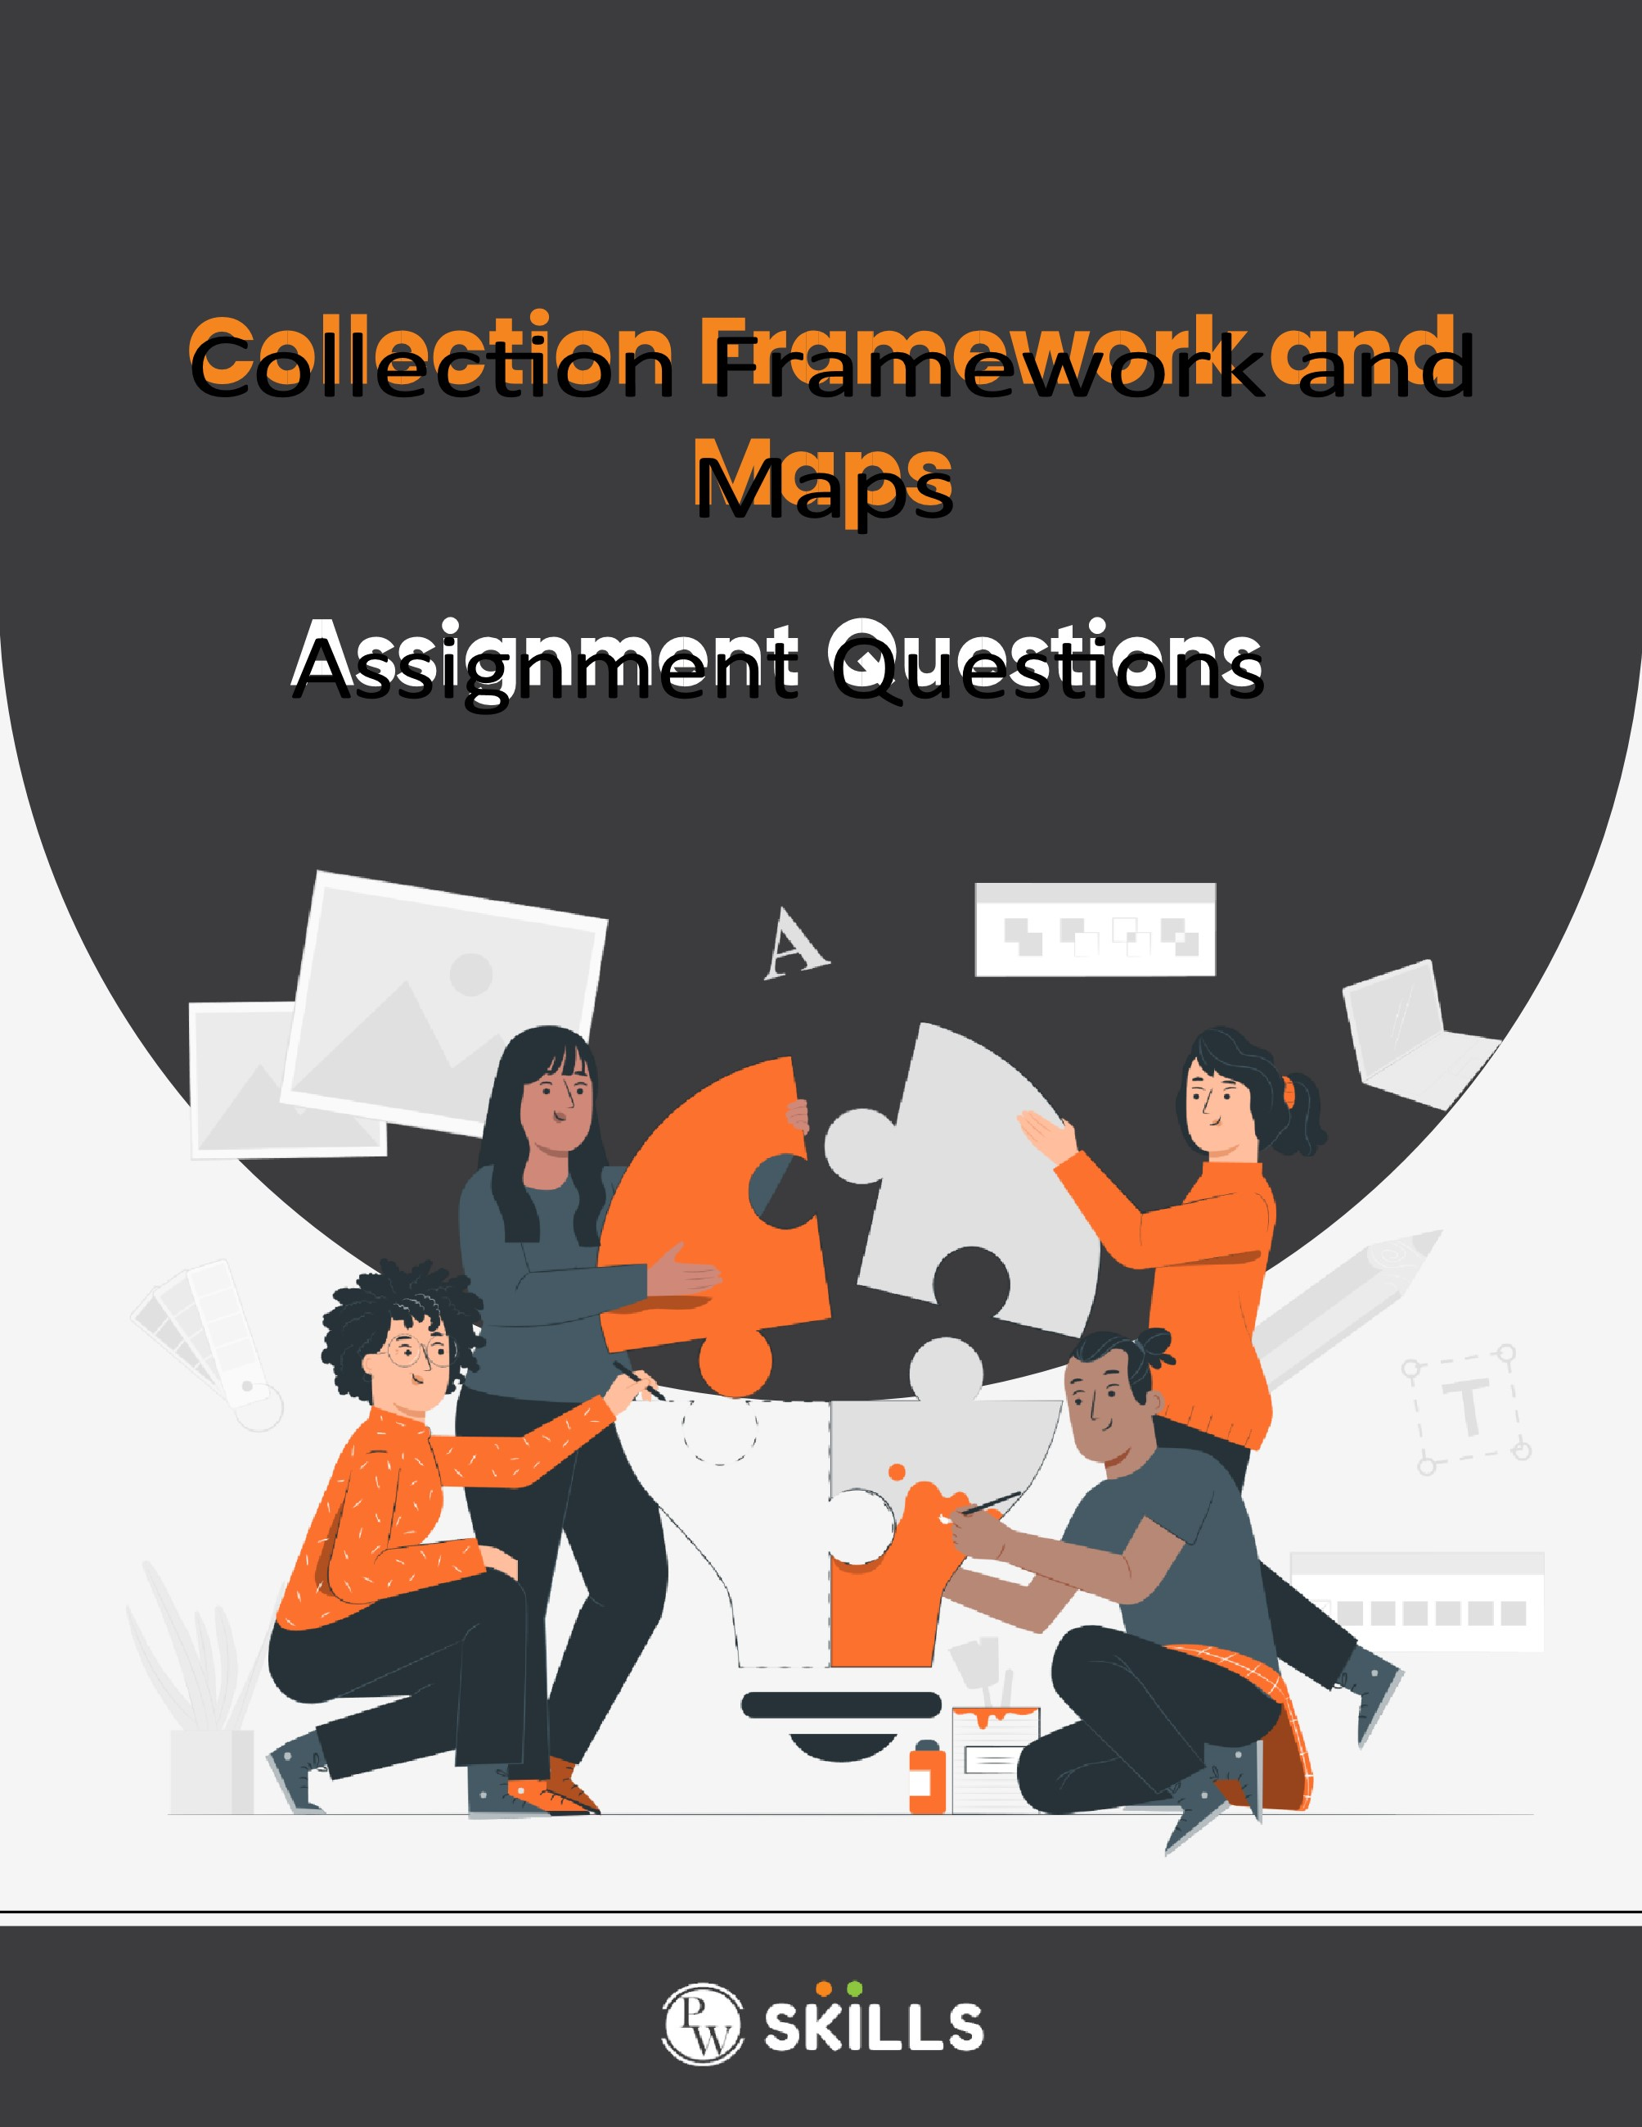

1. What is the Collection framework in Java?

It is a hierarchy that provides different interfaces such as sets, lists, queues, and deques, and classes like ArrayList, LinkedList, Vector, etc. In simple terms, it is a framework that allows us to store and manipulate data, where all the data is stored as an object.

1. What is the difference between ArrayList and LinkedList?

ArrayList:

* It internally uses a dynamic array to store elements.
* ArrayList implements the List interface.
* Representation of ArrayList: ArrayList al1=new ArrayList();

al1.add(100)

S.O.Pln(al1);

LinkedList:

* It internally uses a doubly linked list to store elements.
* Linked list implements the list and deque interfaces(it can act as a list and queue)
* Representation of LinkedList: LinkedList al1=new LinkedList();

al1.add(100)

S.O.Pln(al1);

1. What is the difference between Iterator and Listlterator?

ITERATOR:

* We can get an iterator cursor by the iterator()method.

Iterator itr=l.iterator();

* Iterator curson can be use with any collection object.
* Iterator method are hasNext(), next(), remove()
* In iterator we can retrieve the element only in the forward direction
* We can read and remove element by using iterator.

LISTITERATOR:

* We can get an ListIterator cursor by the listIterator()method.

ListIterator itr=l.lisIiterator();

* listIterator cursor can be use with only arraylist, linkedlist, vector, stack.
* Iterator method are hasNext(), next(), remove(), hasprevious(), Previous(), remove(), set()
* In iterator we can retrieve the element in the forward and backward direction
* We can read, remove, replace and add element by using listiterator.

1. What is the difference between Iterator and Enumeration?

**Iterator:**

* We can get an iterator cursor by the iterator()method.

Iterator itr=l.iterator();

* Iterator cursor can be use with any collection object.
* Iterator method are hasNext(), next(), remove()
* In iterator we can retrieve the element only in the forward direction
* We can read and remove element by using iterator.

**Enumeration:**

* We can get an enumeration cursor by the elements()method.

Enumeration e=v.elements();

* enumeration cursor can be use with only legacy classes i.e vector and stack.
* enumeration method are hasMoreElement(), nextElement()
* In enumeration we can retrieve the element only in the forward direction
* We can read element by using enumeration.

1. What is the difference between List and Set?

**LIST:**

* List is an index-based data structure
* We can store duplicate elements
* Order of insertion is maintained
* We can iterate the list element by Iterator and list iterator

**SET:**

* List is not an index-based data structure
* We cannot store duplicate elements
* Order of insertion is not maintained
* We can iterate the list element by Iterator only

1. What is the difference between HashSet and TreeSet?

**HashSet:**

* It is an implement class of set interface
* Syntax:-

Class HashSet implement set

{

}

* It follows the Hashtable method
* It does not follow the order of insertion
* Does not arranged in sorted order

**TreeSet:**

* It directly implement class of Navigable set but indirectly implements sorted set and set interface interface
* Syntax:-

Class TreeSet implement NavigableSet

{

}

* It follows the Balance tree method
* It does not follow the order of insertion
* Elements are arranged in sorted order of tree.

1. What is the difference between Array and ArrayList?

**Array:-**

* A static type, it is of fixed-size data structure.
* It supports both primitive types and objects.
* It can be Multi-dimensional
* Part of core java
* Syntax:-

Int array1[]=new Int[5];

**ArrayList:-**

* A dynamic type, it is of resizable collection class.
* Can only store objects.
* One dimensional.
* Part of the collection framework.
* Syntax:-

ArrayList itr=new ArrayList();

1. What is a Map in Java?
2. It is a part of collection framework.
3. A map is an interface that represents a collection of key-value pairs, where each key and value pair known as entry.
4. A map is useful if you have to search update or delete elements on hierarchy
5. In map key should be unique.
6. Map does not follow sorted and insertion order.
7. What are the commonly used implementations of Map in Java?
8. What is the difference between HashMap and TreeMap?

**HashMap:**

* Hashmap implements class of map interface

Class hashmap implements Map{

}

* Hashmap follows hashtable method
* Hashmap stores the values in key-value pair
* Hashmap can store heterogenous element
* It does not follow sorted and insertion order

**TreeMap:**

* Treemap implements a class of Navigable maps but its also inherits properties of the sorted map and map interface

Class hashmap implements Map{

}

* Hashmap follows hashtable method
* Hashmap stores the values in key-value pair
* Hashmap can store heterogenous element
* It does not follow sorted and insertion order

1. How do you check if a key exists in a Map in Java?

Using containsKey():

* The containsKey() method checks whether a specific key is mapped in the Map.
* If the key exists, it returns true, otherwise, it returns false.

Cracking the Coding Interview in Java - Foundation